QD_Exercise
Project Names
 | Project Name | Purpose
1 | QFConsoleApp | Main program for starting web api service
2 | QFEFCoreWrapper | Class library for SQLite using EF-DB First
3 | QFWebApiCore | ASP.Net Core MVC Web Api
4 | Common | Contains commonly used interfaces for unit test and application
5 | UnitTest | Unit tests

Database
SQLite is chosen for purpose of this demo, for its lightweight portability.
Location: QFWebApplication1\DB\DBLite\CompanyDB.db
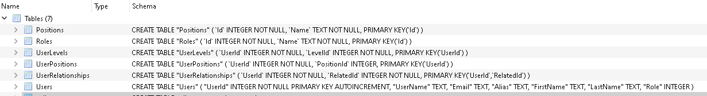
Relational design:
UserRelationships.RelatedId => Users.UserId (Relates Managers to Clients in Users table)
Users.RoleId => Roles.Id, Users.Role => Roles.Id
Users.UserId => UserPositions.UserId, UserPositions.PositionId => Positions.Id
Users.UserId => UserLevels.UserId, UserLevels.LevelId => Levels.Id

Running the web api
Run QFConsoleApp to start the web API.
Usage
Open a browser and send the following sample urls:
Get all users
http://localhost:5000/api/users/
Add new user
http://localhost:5000/api/users/New?userName=test123&alias=testAlias&firstName=Tester&lastName=One&email=testemail&roletype=client
Get all managers with their associated clients
http://localhost:5000/api/managers/
Get all clients with their associated managers
http://localhost:5000/api/clients/
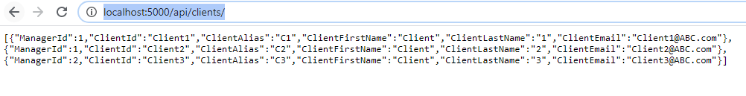
Get all users (clients) belonging to a managerId=1
http://localhost:5000/api/clients/1

Unit Tests
UnitTestDBRoles.cs
TestMethodReadDBValues – Tests reading of Database table Roles
UnitTestWebApi.cs
TestMethodGetRoles – Tests web api level of reading of Database table Roles

